ssm-java-Eclipse-codeStyle-codeTemplate.xml
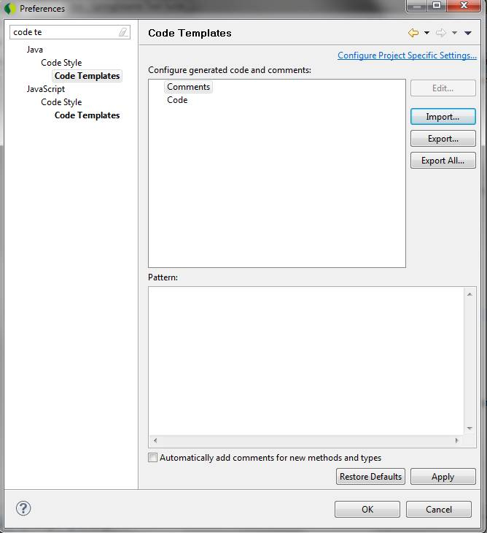

ssm-java-Eclipse-codeStyle-formatter.xml

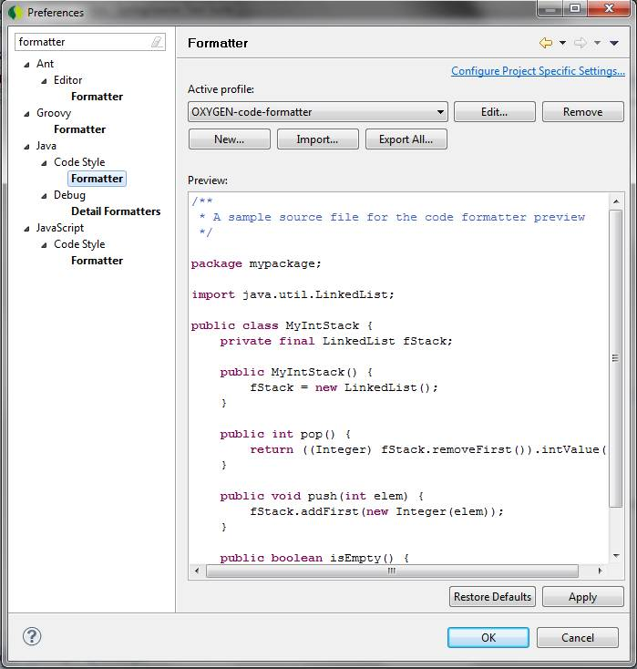

ssm-java-Eclipse-editor-templates.xml
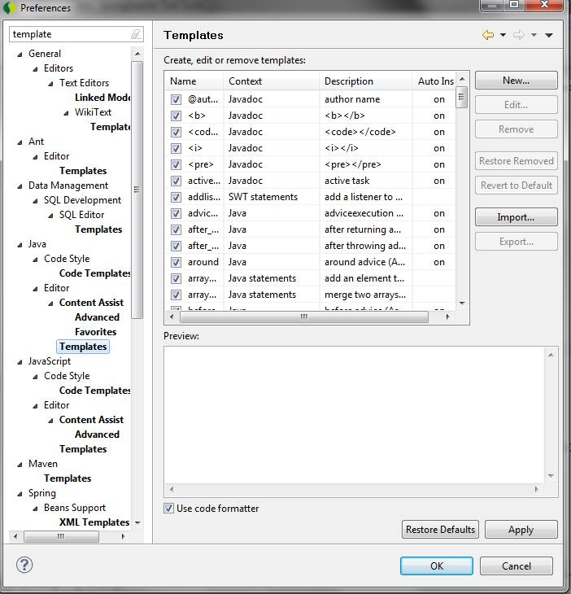

ssm-checkstyle-sun-eclipse.xml

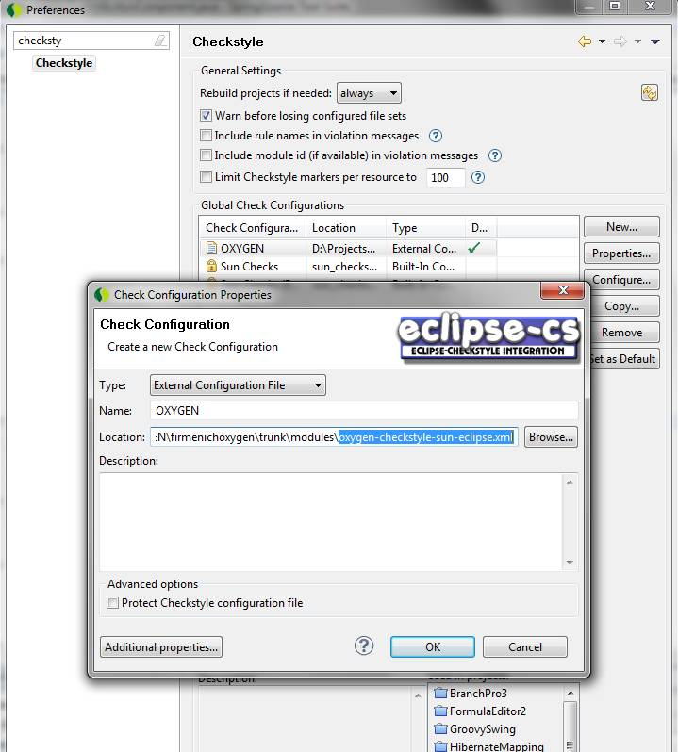

Then, add additional properties checkstyle.suppressions.file vao checkstyle configuration OXYGEN

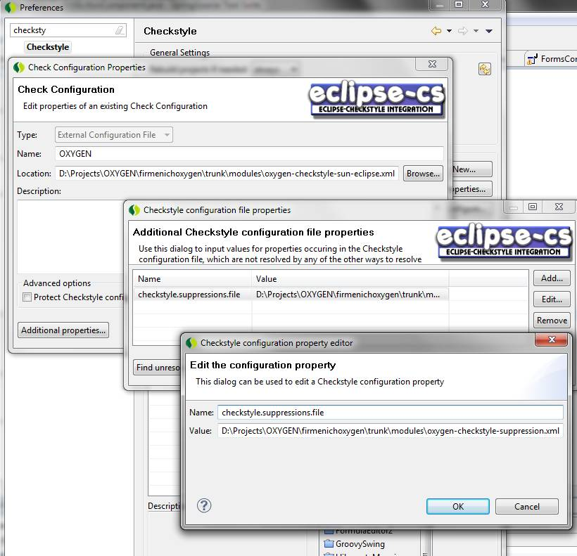

Notes: if you do not find Checkstyle in STS preferences box. Read & follow this http://eclipse-cs.sourceforge.net/downloads.html then restart eclipse

- Auto format code when saving:
- 